Information kit
for NDIS participants, families and carers
The NDIS Quality and
Safeguards Commission
1 July 2018

Contents
About this kit 3
Who is it for? 3
If you have questions 3
Information about the NDIS Commission 4
What does the NDIS Commission mean for you? 4
What does the NDIS Commission expect from providers and workers? 4
If you feel unsafe or unhappy with your NDIS services 5
When is the NDIS Commission available in other states and territories? 5
What about the NDIA? 6
If you are unhappy with the NDIA 6
Information for families and carers 7
Do you manage your own plan? 7
More information 8
Contact the NDIS Commission 8
Visit the NDIS Commission website 8
How to make a complaint 8
Publications for participants, families and carers 9
Publications for providers 9

About this kit
This kit provides information about a new independent Commonwealth agency called the NDIS Quality and Safeguards Commission (NDIS Commission) and what it means for NDIS participants in South Australia and New South Wales.

Who is it for?
This kit is for NDIS participants, including participants who manage their own plan.
This kit also has information for families and carers.
We have sent tailored information kits to NDIS planners, Local Area Coordinators (LACs), Early Childhood Early Intervention (ECEI) partners, governments, advocates and provider peak bodies.

If you have questions
After you read this kit, you might have questions or want to know more. You can:
- Phone us – 1800 035 544
- Visit our website www.ndiscommission.gov.au
- Read our publications or Easy Read materials – there is a list on page 9
- Talk to a family member, friend, carer or advocate
- Talk to your NDIS planner, Local Area Coordinator or ECEI partner
- Talk to your provider.

Information about the NDIS Commission
The NDIS Quality and Safeguards Commission (NDIS Commission) is a new independent Commonwealth agency that will help improve the quality and safety of NDIS supports and services.
The NDIS Commission is now available in your state.
The NDIS Commission starts on:
- 1 July 2018 in New South Wales and South Australia
- 1 July 2019 in the Australian Capital Territory, Northern Territory, Queensland, Tasmania and Victoria
- 1 July 2020 in Western Australia.
By 1 July 2020, the NDIS Commission will be available in all states and territories.
The NDIS Commission, when fully rolled out, will promote quality and safe services for all participants no matter where they live.

What does the NDIS Commission mean for you?
A strong and nationally consistent quality and safeguards system is now in place in your state.
The NDIS Commission can help resolve concerns or complaints about NDIS supports and services.
All NDIS providers and workers in your state must follow a new NDIS Code of Conduct. The Code sets out the standards of quality and safety expected for NDIS services and supports.
We have the power to take action if a provider or worker does not meet the new NDIS Code of Conduct.
A new national worker screening system is being developed and will soon be in place in your state. Worker screening is a way to check that people who wish to work with NDIS participants can be trusted to work with people with disability. Until the new system is in place, existing worker screening and police check requirements in your state will continue.
Over time, we will identify improvements to the NDIS that will benefit everyone.

What does the NDIS Commission expect from providers and workers?
We expect all NDIS providers and workers in your state to:
- provide you with safe, quality supports and services
- uphold your right to be free from harm
- follow the new NDIS Code of Conduct.
In addition, we require all registered providers in your state to:
- have a complaints system in place, and manage the complaints they receive
- meet the new NDIS Practice Standards
- report certain types of incidents to the NDIS Commission, including incidents or allegations of abuse and neglect
- report the use of restrictive practices and behaviour support plans, with the aim of reducing and eliminating restrictive practices.
We will educate providers and workers to meet their responsibilities.

Is your provider registered or unregistered?
Not all providers need to be registered with the NDIS Commission, but most are.
Only registered providers can work with people that have National Disability Insurance Agency (NDIA) managed plans.

If you feel unsafe or unhappy with your NDIS services
You have the right to be safe and to receive quality services from the providers and workers you choose to support you under the NDIS.
If you feel unsafe or unhappy with your NDIS services, you have the right to complain.
It’s OK to complain. Speaking up can help improve services for you – and other people.
If you have a concern, try talking to your provider first. You can ask someone you trust, or an independent advocate, to help you.
If you don’t want to talk to your provider or are unhappy with their response, contact the NDIS Commission.
We will help try to resolve your concerns.
We will work with you, providers and workers to improve the quality and safety of NDIS supports and services – for you and all participants.
Our brochure How to make a complaint has more information.

When is the NDIS Commission available in other states and territories?
The NDIS Commission starts on:
- 1 July 2018 in New South Wales and South Australia
- 1 July 2019 in the Australian Capital Territory, Northern Territory, Queensland, Tasmania and Victoria
- 1 July 2020 in Western Australia.
NDIS participants are covered under their state or territory’s existing quality and safeguards systems until the NDIS Commission is available.

What about the NDIA?
The NDIS Commission does not replace the National Disability Insurance Agency (NDIA).
The NDIA will continue to:
- deliver the NDIS
- provide individualised plans and support people with disability
- coordinate service bookings, payments and access to plans for providers
- handle complaints about the NDIA itself, eligibility funding and participant plans.
The NDIA will share news and information with participants about the NDIS Commission, through the myplace participant portal, NDIS newsletters and NDIS participant information sessions.

If you are unhappy with the NDIA
The NDIS Commission does not handle complaints about the NDIA.
If you are unhappy with the NDIA and want to make a complaint, contact the NDIA:
- Phone 1800 800 110
- Visit an NDIA office
- Complete a complaints form and:
  - email it to feedback@ndis.gov.au
  - post it to National Disability Insurance Agency, GPO Box 700, Canberra ACT 2601
  - drop the form off at an NDIA office.
For the complaints form and a list of NDIA offices, visit www.ndis.gov.au
If you are not satisfied with the NDIA’s response to your complaint, you can contact the Commonwealth Ombudsman. Phone 1300 362 072.

Information for families and carers
If you are a family member or carer of an NDIS participant, you can help by:
- reading the information in this kit
- ensuring participants read and understand the information in this kit
- ensuring participants understand they have the right to receive safe and quality services from providers and workers
- talking to the NDIS planner, LAC or ECEI partner about any concerns you or the participant may have about supports and services
- supporting participants to raise their concerns with the provider or NDIS Commission
- visiting the NDIS Commission website www.ndiscommission.gov.au to find out more.
Family members and carers can also contact the NDIS Commission to raise a concern or make a complaint on behalf of a participant.

Do you manage your own plan?
Most NDIS participants choose to have the NDIA or a Plan Manager manage their plan. Some participants manage their own plan, or appoint a nominee.
If you manage your own plan, or have a nominee:
- you can continue to choose to engage registered or unregistered providers to support you
- if your provider delivers high-risk or complex services to you, they must be registered with the NDIS Commission
- we encourage you to ensure that your providers (registered and unregistered) and workers are aware that they must follow the new NDIS Code of Conduct
- you can give your providers and workers a copy of the new NDIS Code of Conduct – it’s available on our website www.ndiscommission.gov.au
- we encourage you to talk to your providers or workers if you are concerned about the quality or safety of supports and services they deliver to you
- you can raise a concern or make a complaint to the NDIS Commission
- you have the right to tell NDIS workers working with you to have an NDIS Worker Screening check once the new NDIS worker screening system is in place.

More information

Contact the NDIS Commission

Call us
Phone the NDIS Commission on 1800 035 544.
We are available Monday to Friday, 9 am to 5 pm Australian Eastern Standard Time.
It is free to phone from a landline telephone. Calling from a mobile phone may incur a charge.
National Relay Service
Visit www.relayservice.gov.au then
Voice: 1800 555 660
TTY: 1800 555 630
Translating and Interpreting Service
Phone 131 450

Email us
feedback@ndiscommission.gov.au

Visit the NDIS Commission website
Visit our website www.ndiscommission.gov.au for information about:
- how to raise a concern or make a complaint
- start dates for the NDIS Commission
- information about NDIS Commissioner Mr Graeme Head and staff
- the NDIS Code of Conduct for all providers and workers
- guidance for providers about registration, the NDIS Practice Standards, reporting and managing incidents, reporting restrictive practices and behaviour support plans
- legislation, rules and policies.

How to make a complaint
Call us on 1800 035 544.
Submit the complaint contact form online at www.ndicommission.gov.au

Publications for participants, families and carers
The following publications are available on our website www.ndiscommission.gov.au
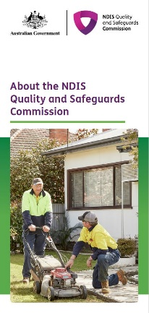 | Overview of the NDIS Quality and Safeguards Commission  This fact sheet explains what the NDIS Commission does, when we are available in other states and territories, and what it means for NDIS participants and providers.
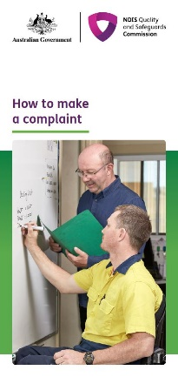 | How to make a complaint  This is a brochure for NDIS participants and their families, carers, advocates and workers. It explains how people can make a complaint to the NDIS Commission.

Publications for providers
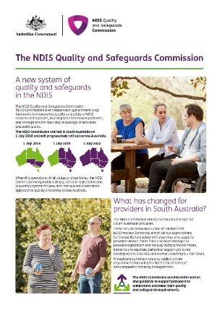 | What’s changed for South Australian providers?  This fact sheet explains what is changing for South Australian providers from 1 July 2018.
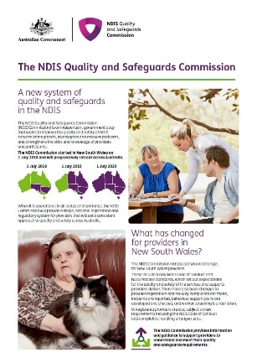 | What’s changed for New South Wales providers?  This fact sheet explains what is changing for New South Wales providers from 1 July 2018.
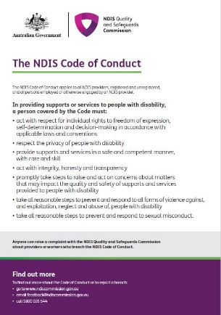 | Code of Conduct  This fact sheet explains the new NDIS Code of Conduct, which now applies to providers and workers in South Australia and New South Wales.
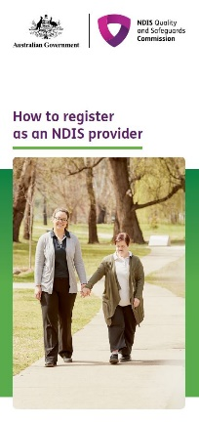 | How to register with the NDIS Commission  This fact sheet explains which providers need to register with the NDIS Commission, the registration process, and how providers are assessed against the NDIS Practice Standards.

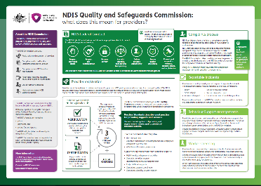
Provider obligations – NDIS Commission
Poster outlining provider obligations under the NDIS Commission.

