

**Speak up and complain**

**Rights**

**Have**

**We**

**You have the right to:**

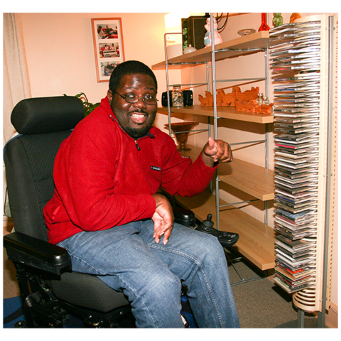

**Live in your own home**

**You have the right to:**

**Not live in an institution**

**You have the right to:**

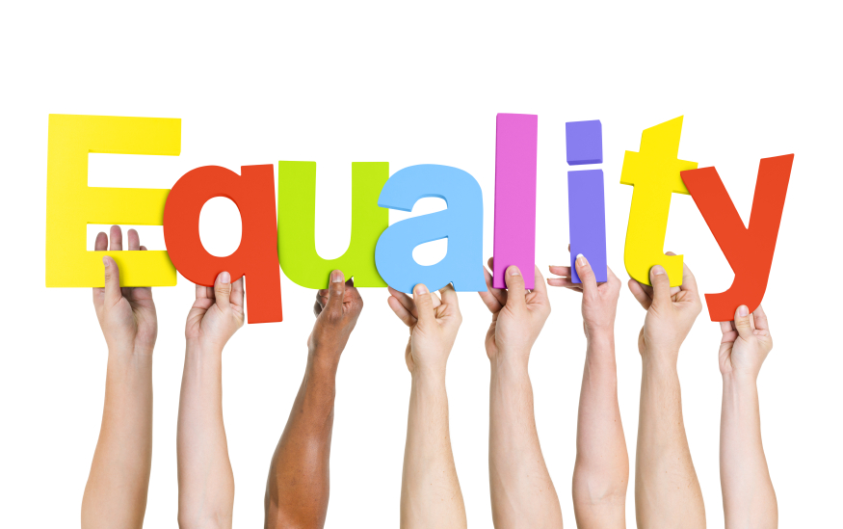

**You have the right to:**

**Be treated the same as anyone else**

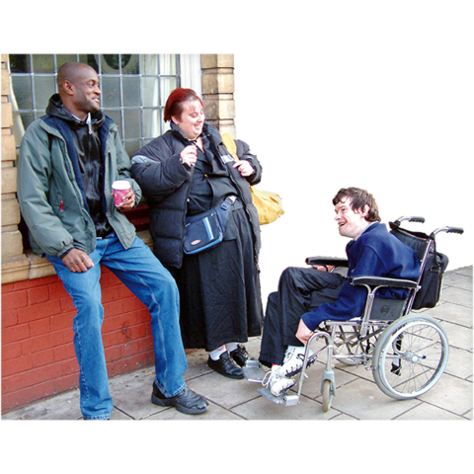

**Be free to go wherever you want**

**You have the right to:**



**Have a well-paid job**

**You have the right to:**

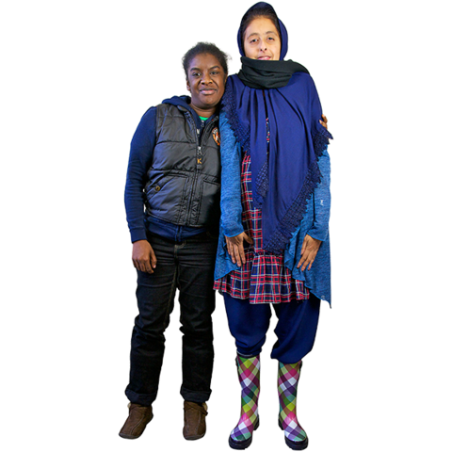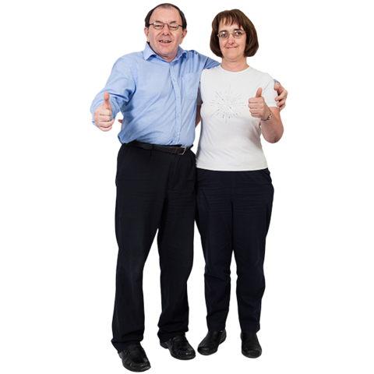

**A relationship and to have a family**

**You have the right to:**

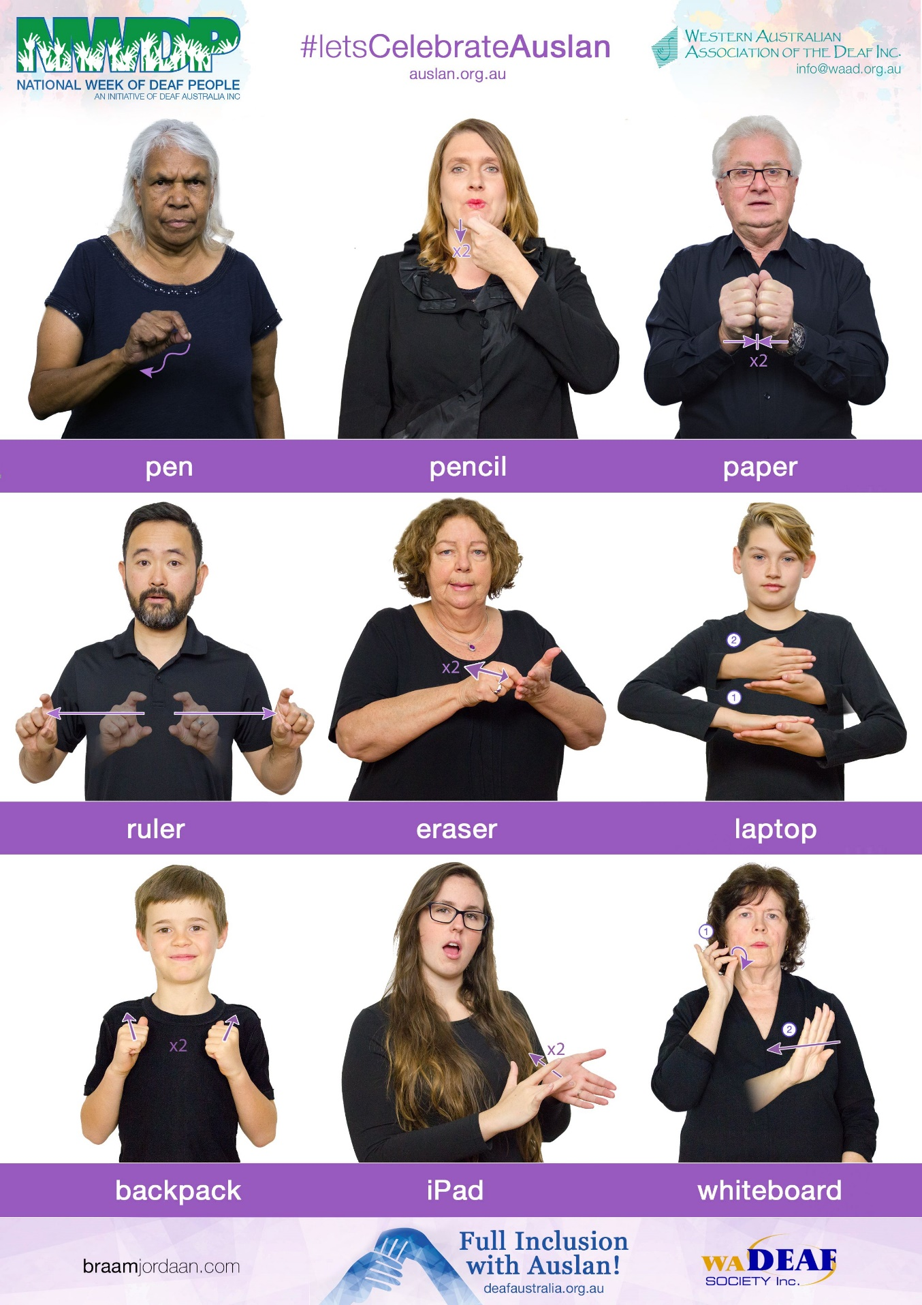

**Information you can understand**

**You have the right to:**



**No policies or**

**decisions should**

**be made about**

**people with a disability without people with a disability.**



**Not be treated differently because you have a disability**

**You have the right to:**



**You have the right to:**

**Be safe and to not be abused**