1  Who runs self advocacy groups? | 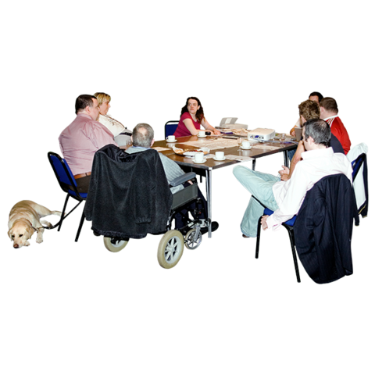  2  Have you ever been in a meeting? How was it?
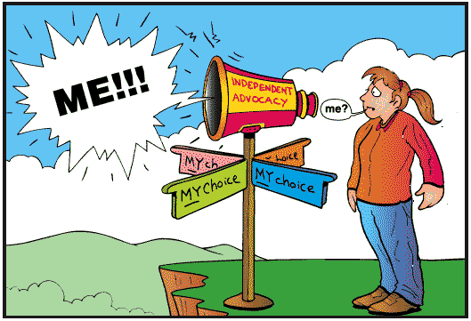  3  Why is self advocacy important? | 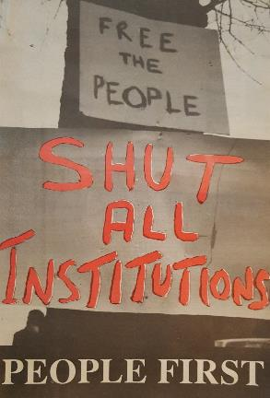  4  Self advocacy groups make change happen. What would you change to make life better for people with disabilities?
5  Ask the person next to you what they know about self advocacy. | 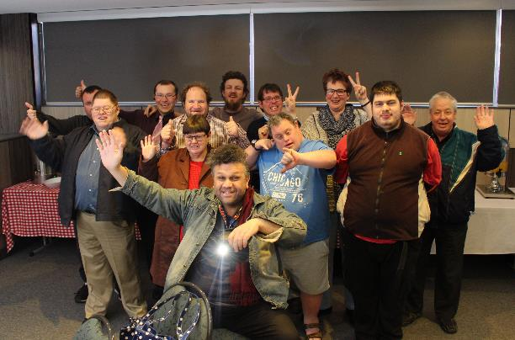  6  What fun activities could your  self advocacy group do?
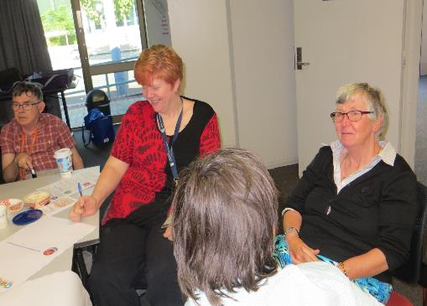  7  Are you interested in starting a self advocacy group? Why? | 8  What human right is  important to you?
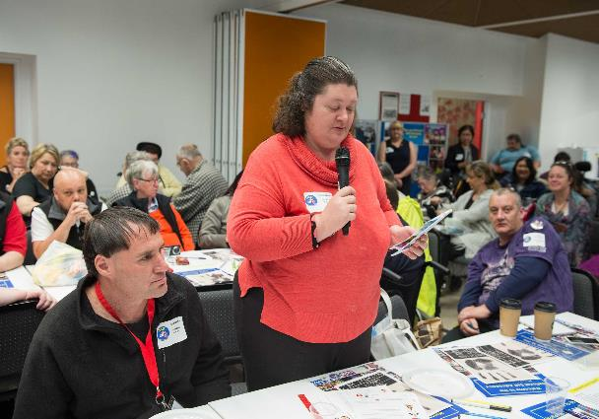  9  Why is it important to join together to speak up for  your rights? | 10  What does the saying  “Nothing About Me without Me”  mean to you?
11  What would you like to change  in your life? | 12  What do you think about the self advocacy videos we watched?
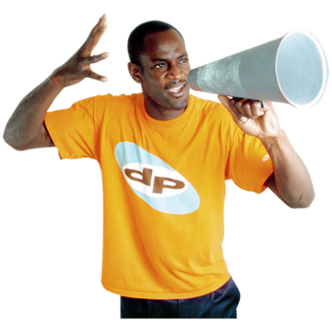  13  How do self advocacy groups help you to speak up? | 14  Name 2 new things you would like to learn in your self advocacy group.
15

Do you like Bingo?

